Initial investigation of free-breathing 3D whole-heart stress myocardial perfusion MRI

Supplementary Material

S1 - Appendices
A1 - Whole heart stack-of-stars first-pass-perfusion (3D-SOS-FPP) method
A2 – Shot duration minimisation
A3 – RF pulse optimisation
A4 - STCR reconstruction and L-curve optimisation
A5 - 2D CMR FPP acqusition details

A1 – Whole-heart stack-of-stars first-pass-perfusion (3D-SOS-FPP) method
A saturation recovery spoiled gradient-echo (SGRE) sequence was modified to support the stack-of-stars (SOS) [1] trajectory (Figure A1.1). All gradient pulse amplitudes, durations and ramp slew-rates were designed for fastest operation subject to hardware performance and peripheral nerve stimulation and the sequence optimised to provide a shortened acquisition time (section A2). The slab-excitation RF duration was minimised for the prescribed flip angle by using the peak RF voltage available (section A3). With the modifications listed in sections A2 and A3, the 3D-SOS-FPP shot duration was reduced to 188ms, considered important to minimise intra-shot motion.
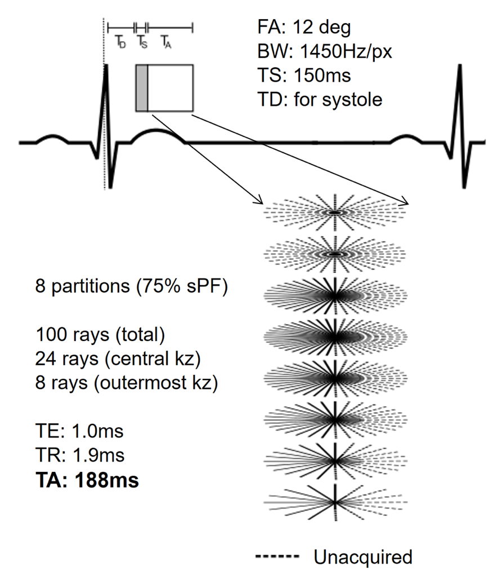
Figure A1.1: The 3D-SOS-FPP sequence as applied consistently in all subjects. The solid lines of the k-space path were acquired, collecting those shown in each partition before stepping to the next partition (upwards from the base of the figure). Dashed lines represent regions of k-space that were not acquired.
Following ECG triggering, a delay synchronised the 3D-SOS-FPP central raw data acquisition with the end-systolic pause, previously assessed using a cine scan in each subject. Non-selective saturation of Mz was performed before each 3D-SOS-FPP shot. A 3-pulse composite RF saturation method was applied for improved consistency of saturation in the presence of B0 and B1 distortions [2], followed by a 150ms saturation “free recovery” delay before the FPP shot started (Figure A1.1) .

The 3D-SOS-FPP was reconstructed with a spatio-temporally constrained reconstruction (STCR), a compressed sensing reconstruction implementing both spatial and temporal weighting [1], [3], [4]. Prior to STCR, principal component analysis-based coil channel reduction to eight channels was applied to reduce the reconstruction time [5]. Reconstruction of the FPP datasets used the pre-interpolated STCR algorithm, with temporal total-variation (TV) constraint weighting α = 1.0x10⁻⁰⁴, and spatial TV constraint β = 7.5x10⁻⁰⁵ with a fixed number of 50 iterations [1]. A TV constraint in the through-plane (slice) direction was further added, similar to those used in-plane, because there were only relatively gradual changes in this direction, with its own weighting factor, γ = 5.0x10⁻⁰⁵. After initial “L-curve” optimisation of the reconstruction parameters, as described in section A2, all factors in the reconstruction were held constant across all of the subjects. After STCR reconstruction, zero-padding was performed in k-space for the partition-encoding direction, to provide interpolated slices and assist with clinical interpretation. The reconstruction of an in vivo 3D-SOS-FPP dataset took approximately 25 minutes. (Matlab programming, i5 Xeon 3GHz CPU, 64GBytes RAM).

A2 – Shot duration minimisation
The following modifications were applied in order to reduce the 3D-SOS-FPP shot duration to 188ms:

Each 3D-SOS-FPP shot acquired 24 rays in the central partition reducing to 8 in the outermost partition (details in variable undersampling section below), acquiring 6 kz partitions by partial sampling in the slice direction, a total of 98 rays acquired per 3D-SOS-FPP shot, using TR = 1.9 ms and TE=1.0ms. The average flip angle (using calibration from a transverse slab through the isocentre) was set to 12° (although it is recognised that flip-angle varies with B1 nonuniformity across the heart). The ray acquisition order was sequential within each partition, rotating up to 180 degrees, proceeding through the kz direction in linear order beginning from the base (see Figure A1.1). Each ray readout was rate 2 oversampled, taking 216 samples over (nominally) 600mm diameter (1.1us/sample) radially, by 75% asymmetric echo sampling (i.e. the solid lines of the k-space path diagram in Figure A1.1 were acquired, and data on dashed lines was zero-filled). The nominally acquired spatial resolution was 2.1 x 2.1 x 10mm. Randomised RF phase spoiling was applied [6] which minimised TR through avoiding the need of aditional spoiling gradients, to further reduce the shot-duration.

After initial testing in phantoms, both readout sampling asymmetry (rPF) and slice-direction partition encoding asymmetry (sPF) were set as “75%” (i.e. omitting −k_{max} to −k_{max/2} and sampling only −k_{max/2} to +k_{max}); this degree of partial acquisition is commonly used in zero-filled partial Fourier applications [7]. Reasonable accuracy can usually be achieved with the zero-filled method at this degree of acquisition [8], albeit with increased Gibbs ringing due to the sudden truncation of acquired frequencies. Application of a windowing function to reduce this truncation effect is possible, but with a potential consequence of reduced image resolution.

A further reduction in the shot duration was gained through so-called variable undersampling (VU) of the number of rays per partition. This technique maintains (or increases) the number of rays in the central kz partition, instead shortening the shot duration by lowering (further undersampling) the number of rays acquired in the outer partitions. The undersampling was increased for higher k_{z} i.e. with increased k-space distance from k_{z} = 0. By focussing the sampling towards the centre of k-space, VU aims to combine an important reduction in shot duration with minimising the associated reduction in image quality.

Three potential VU schemes were compared, chosen to test different compromises between increased number of central rays and faster drop-off towards the edge partitions. The three VU schemes, implemented with 75% slice-PF, were: VU(1)=(12-14-16-18-20-18-0-0), VU(2)=(8-12-16-20-24-20-0-0) and VU(3)=(4-10-16-22-28-22-0-0). The total number of rays for these three methods were therefore 98, 100 and 102 - resulting in a relatively consistent 3D SOS shot duration (difference < 8ms). For initial phantom testing, the three VU methods were implemented in the SOS sequence, along with a non-VU equivalent (20-20-20-20-20-20-0-0). The resulting images across all the slices are shown in Figure A2.1. The image quality remained fairly consistent between those acquired with the non-VU sequence and those acquired with all three of the VU methods. A slight improvement of in-plane sharpness is visible with increasing central ray number. However, examination of a line profile drawn horizontally through the central region of the phantom (which contained an oblique wedge of fluid signal that provided some indication of partition-encoding fidelity) demonstrated the negative impact on the partition-encoding fidelity (Figure A2.2). This was caused by the sharper drop-offs in ray numbers that are required because of the increased central ray number. From this it is hypothesised that with a greater number of rays in the central partitions of k-space, structures in the phantom that did not vary along the partition-direction showed an improved sharpness. However, the central “tilted wedge" of signal showed clearly that the partition-encoding was losing fidelity when applied with a steeper drop in ray-numbers. Therefore, the VU(2) scheme was selected as the compromise between providing clearer in-plane results and maintaining the partition-encoding accuracy. The application of this VU scheme reduced the shot duration by 16.7% of the duration of the Non-VU scheme.
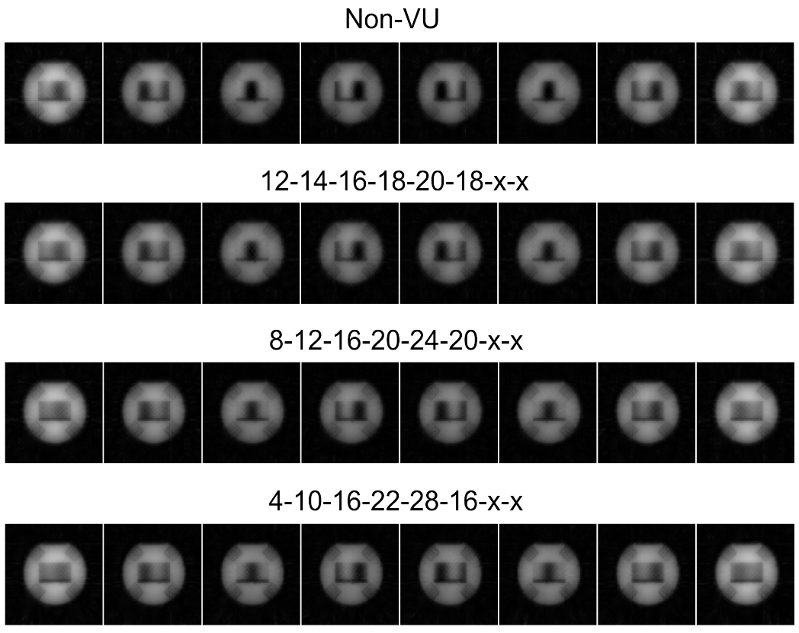
Figure A2.1 - All eight slices of a phantom dataset acquired with the three variable undersampling (VU) methods, as well as the non-VU method.

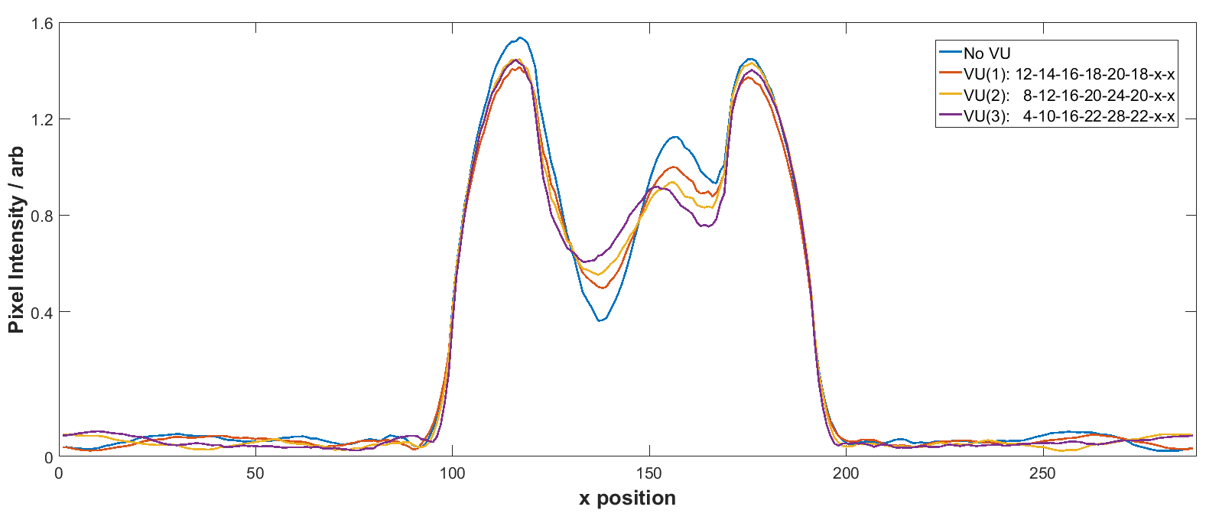
Figure A2.2 - Variable undersampling line profiles. A horizontal central line profile taken from the centre slice of the phantom images in Figure A2.1, plotted for each of the variable undersampling methods. With increased VU the line profile begins to smooth the oblique wedge variation, due to degraded partition voxel sharpness.

A3 – RF pulse optimisation
The fast sequence operation demanded very short excitation RF pulses and their design took advantage of the low flip-angle required i.e. that these would not be expected to deliver more than about 12°. It was carefully tested that if the maximum transmitter RF peak power were reached, this did not clip the peak and distort the slab profile, rather the entire RF pulse waveform was scaled down so that no slab profile distortion occurred, only a reduction of the achieved flip-angle. It appears to be a limitation of some 3T scanner designs, that the peak B1 is insufficient; a low-SAR sequence such as this application might reasonably request a very high peak B1 at low duty cycle.

A4 - STCR reconstruction and L-curve optimisation
Optimisation of compressed-sensing reconstruction methods often uses retrospectively subsampled data. This allows the root-mean square error of tested reconstructions to be compared with the reconstruction of the “ground-truth" data, that had been obtained by complete k-space sampling. However, for this 3D-SOS-FPP work, such ground truth data clearly cannot be acquired at the temporal resolution required. Any attempt to do so would produce images with such different characteristics that any notionally optimal weights derived would likely no longer be applicable for the prospectively undersampled acquisitions. Therefore, the retrospective subsampling approach to optimising the weights was not adopted in this work.

Instead, the L-curve method [9] is a technique for finding a weighting value that provides the best compromise between the terms being minimised, without the requirement for ground-truth data. The “L-curve" is a description of the parametric log-log plot of the two costs involved in the reconstruction method, where a point is plotted for each reconstruction that uses a different weighting value. The term L-curve is used due to the typical shape of the distribution of these points on the plot (Figure A4.1), with an elbow in the curve occurring around a certain weighting value. The weighting that yields the best compromise between the two costs is therefore near this corner, where both cost values remain low. The L-curve method has often been used for parallel imaging methods that employ regularisation, to explore the best compromise between the regularisation of the data and its fit to the original data [10]. For STCR, the L-curve method can be performed to find the best compromise between the terms in its cost function: the sparsity constraint (L2-norm cost term) and the data fidelity (L1-norm cost term) [11]. N.b. the L symbols used for the “length” norms are unrelated to the “L" in the L-curve name that simply refers to the typical shape of that curve.
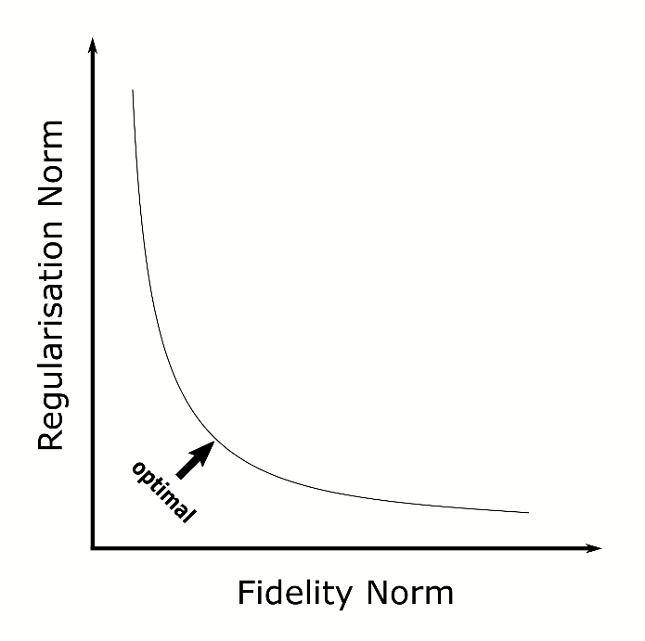
Figure A4.1 - The L-curve appearance. An L-curve, as often used in regularised parallel imaging, will typically follow the above pattern. An optimal weight value will produce a point in the ‘corner’ region of the curve. This provides a compromise between fitting to the original data (data fidelity) and to some other information (regularisation, or for STCR - spatio-temporal constraints).

For three initial test in vivo datasets that had been acquired at rest during GBCA first-pass with the finalised 3D-SOS-FPP sequence, reconstructions were performed with different weighting factors to produce L-curve plots. To optimise the temporal constraint weight value, the spatial constraint weights were set to zero, and a range of 15 temporal weights, α, were used. An initial series of temporal weights was chosen to give equal coverage over a large range, based on experience with the weights in early testing of 3D-SOS-FPP datasets. Following the results from the initial series, more weights were then chosen in the segment of most interest along the curve, i.e. traversing the corner. The same final set of weights were used to reconstruct all three datasets.

Figure A4.2 shows the L-curves for the three datasets, using the same axes. The values of the norms can be seen to vary between the datasets, but the location of the “elbow" in the L-curve was in a relatively consistent range of temporal weights (α). The α = 1.0E-04 point selected for all subsequent reconstructions in this work is in the corner region for each case (arrows). Mathematical methods exist to accurately determine the weighting value at the corner of such curves, technically the point of maximal curvature [9], but a manual identification was considered sufficient for this work.

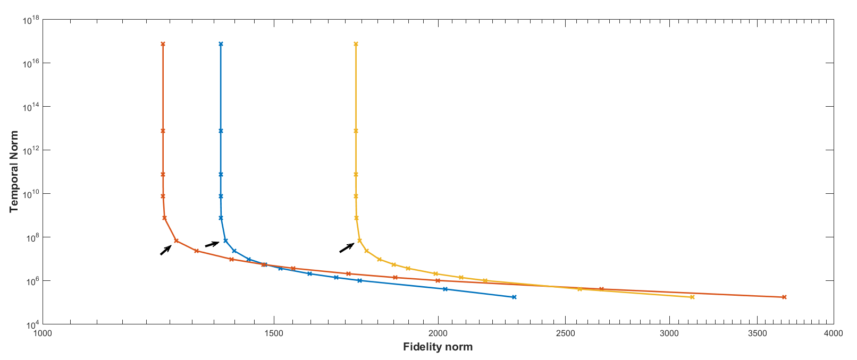
Figure A4.2 - L-curves for 3D-SOS-FPP in vivo datasets with STCR. The α weight values used to produce each point on the curve (from top-left to bottom-right) were: 1.0×10⁻¹³, 1.0×10⁻⁹, 1.0×10⁻⁷, 1.0×10⁻⁶, 1.0×10⁻⁵, 1.0×10⁻⁴, 2.5×10⁻⁴, 5.0×10⁻⁴, 7.5×10⁻⁴, 1.0×10⁻³, 1.5×10⁻³, 2.0×10⁻³, 2.5×10⁻³, 7.5×10⁻³, 1.0×10⁻². α = 1.0×10⁻⁴ was selected as the final weighting value, marked on each curve by an arrow.

Spatial constraints (both in-plane and through-plane) in the STCR method were subsequently analysed. After setting of α = 1.0x10⁻⁰⁴, the entire L-curve plotting process was repeated first for a range of in-plane spatial constraint weights (β) and then for a range of the through-plane spatial constraint weights (γ). From those L-curves (not shown), the weights were optimised as β = 7.5E-05 and γ = 5.0E-05. Literature has previously suggested that the optimised weighting values are robust for a given application [3][4], and the similarity of the corner weight values for the three curves in the three datasets examined here gave confidence that the appropriate values had been identified.

One noticeable effect of the trade-off was in the major defect for the severe CAD case (online movie, M1), where the hypointense region appeared more static across time than the rest of the myocardium, i.e. an “artificial” suppression of respiratory motion by the reconstruction. Alongside the concern that this is affecting a true perfusion defect and what it might do to smaller hypointense regions, this also suggests that further work might be required into the reconstruction method and its temporal weighting. It may be necessary to reduce the temporal weighting further at the expense of reintroducing some residual aliasing. This remains an open question, as optimising reconstruction per individual patient is clinically undesirable. The signal-to-noise of the 3D-SOS-FPP reconstructions was very high, and this is perhaps partly a consequence of the reconstruction, as well as from the 3D encoding.

To determine the possible impact of the STCR reconstruction algorithm on the mild-defect cases, a more simple “gridded” reconstruction, which does not apply compressed sensing or any other correction for the data undersampling, was performed on the individual coil images (Figure A4.3). This allowed examination for the presence of small hypointense regions that may have been smoothed by the STCR reconstruction algorithm. However, the myocardium appeared to have consistent intensity in these images, i.e. no mild perfusion defects were apparent underneath the gridding aliasing.

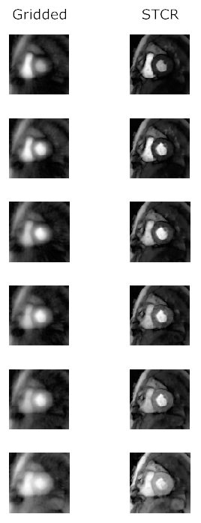
Figure A4.3 - Gridded versus STCR reconstruction comparison. For single slice of the Patient 3 stress dataset, multiple frames for the first-pass of the GBCA are displayed (top-to-bottom). On the left, pre-interpolation gridding only is used for reconstruction, while on the right the STCR reconstruction is used, as described in the methods. No obvious hypointense region, that could match the suspected perfusion defect location, could be seen in either reconstruction.

A5 – 2D CMR FPP acquisition details
Each 8mm myocardial slice included non-selective composite saturation 100ms before each central raw-data acquisition, and chemical-shift based fat suppression, requiring a total 151ms per slice of which image data acquisition took 102ms. Acquired resolution was 1.8mm x 2.3mm (Frequency Encoding x Phase Encoding) using balanced steady-state free-precession (bSSFP) (TE: 1.1ms, TR: 2.5ms) with rate 3 parallel imaging and linearly-ordered acquisition of 41 phase-encoded raw-data lines per image.

Appendix Bibliography

[1] L. Chen, G. Adluru, M. C. Schabel, C. J. McGann, and E. V. R. DiBella, “Myocardial perfusion MRI with an undersampled 3D stack-of-stars sequence,” Med. Phys., vol. 39, no. 8, pp. 5204–5211, 2012, doi: 10.1118/1.4738965.
[2] K. Sung and K. S. Nayak, “Design and use of tailored hard-pulse trains for uniformed saturation of myocardium at 3 Tesla,” Magn. Reson. Med., vol. 60, no. 4, pp. 997–1002, 2008, doi: 10.1002/mrm.21765.
[3] G. Adluru, S. P. Awate, T. Tasdizen, R. T. Whitaker, and E. V. R. DiBella, “Temporally constrained reconstruction of dynamic cardiac perfusion MRI,” Magn. Reson. Med., vol. 57, no. 6, pp. 1027–1036, Jun. 2007, doi: 10.1002/mrm.21248.
[4] G. Adluru, C. McGann, P. Speier, E. G. Kholmovski, A. Shaaban, and E. V. R. DiBella, “Acquisition and reconstruction of undersampled radial data for myocardial perfusion magnetic resonance imaging,” J. Magn. Reson. Imaging, vol. 29, no. 2, pp. 466–473, Feb. 2009, doi: 10.1002/jmri.21585.
[5] G. Adluru and E. DiBella, “Compression2: compressed sensing with compressed coil arrays,” J. Cardiovasc. Magn. Reson., vol. 14, no. S1, p. P242, Dec. 2012, doi: 10.1186/1532-429X-14-S1-P242.
[6] V. Roeloffs, D. Voit, and J. Frahm, “Spoiling without additional gradients: Radial FLASH MRI with randomized radiofrequency phases,” Magn. Reson. Med., vol. 75, no. 5, pp. 2094–2099, May 2016, doi: 10.1002/mrm.25809.
[7] M. J. Fair, P. D. Gatehouse, E. V. DiBella, and D. N. Firmin, “A review of 3D first-pass, whole-heart, myocardial perfusion cardiovascular magnetic resonance,” J. Cardiovasc. Magn. Reson., vol. 17, no. 1, p. 68, Aug. 2015, doi: 10.1186/s12968-015-0162-9.
[8] E. Haacke, R. Brown, M. Thompson, and R. Venkatesan, Magnetic Resonance Imaging: Physical Principles and Dequence Design. Wiley-Liss, 1999.
[9] P. C. Hansen, “The L-Curve and its Use in the Numerical Treatment of Inverse Problems,” in in Computational Inverse Problems in Electrocardiology, ed. P. Johnston, Advances in Computational Bioengineering, 2000, pp. 119–142.
[10] L. Ying, D. Xu, and Z.-P. Liang, “On Tikhonov regularization for image reconstruction in parallel MRI,” in 26th Annual International Conference of the IEEE Engineering in Medicine and Biology Society, 2004. IEMBS ’04, 2004, vol. 1, pp. 1056–1059, doi: 10.1109/IEMBS.2004.1403345.
[11] G. Adluru and E. V. R. DiBella, “Reordering for Improved Constrained Reconstruction from Undersampled k-Space Data,” Int. J. Biomed. Imaging, vol. 2008, 2008, doi: 10.1155/2008/341684.

