Database | Keywords | Results
Embase | ('cardiac amyloidosis' OR 'amyloid cardiomyopathy' OR 'transthyretin amyloidosis' OR 'ttr amyloidosis' OR 'attr amyloidosis' OR 'attr-cm' OR 'hereditary transthyretin amyloidosis' OR 'mutant transthyretin amyloidosis' OR 'wild-type transthyretin amyloidosis' OR 'non-hereditary transthyretin amyloidosis' OR 'light chain amyloidosis' OR 'al amyloidosis' OR 'immunoglobulin light chain amyloidosis') AND ('vutrisiran' OR 'aln-ttrsc02' OR 'amvuttra' OR 'ttr sirna' OR 'rna interference therapeutic' OR 'transthyretin silencing' OR 'ttr gene silencing' OR 'ttr silencer' OR 'sirna therapy') | 358
PubMed | ("Cardiac Amyloidosis" OR "Heart Amyloidosis" OR "Amyloid Cardiomyopathy" OR "Amyloid Heart Muscle Disease" OR "Amyloid Heart Disease" OR "Amyloidosis, Cardiac" OR "Amyloidosis, Hereditary, Transthyretin-Related"[Supplementary Concept] OR "Transthyretin Amyloidosis" OR "TTR Amyloidosis" OR "ATTR Amyloidosis" OR "ATTR-CM" OR “transthyretin amyloid cardiomyopathy”OR "Hereditary Transthyretin Amyloidosis" OR "Mutant Transthyretin Amyloidosis" OR "Wild-Type Transthyretin Amyloidosis" OR "Non-Hereditary Transthyretin Amyloidosis" OR "Senile Systemic Amyloidosis" OR "Light Chain Amyloidosis" OR "AL Amyloidosis" OR "Immunoglobulin Light Chain Amyloidosis" OR "Primary Systemic Amyloidosis") AND ("Vutrisiran" OR "ALN-TTRsc02" OR "Amvuttra" OR "TTR siRNA" OR "RNAi therapeutic" OR "RNA interference therapy" OR "transthyretin silencer" OR "TTR silencer" OR "siRNA therapy" OR "small interfering RNA" OR "transthyretin silencing" OR "TTR silencing" OR "TTR gene silencing" OR "RNAi therapy" OR "TTR mRNA degradation") | 311
Scopus | TITLE-ABS-KEY ( ( ( "Cardiac Amyloidosis" OR "Amyloid Cardiomyopathy" OR "Transthyretin Amyloidosis" OR "TTR Amyloidosis" OR "ATTR Amyloidosis" OR "ATTR-CM" OR "transthyretin amyloid cardiomyopathy" OR "Hereditary Transthyretin Amyloidosis" OR "Mutant Transthyretin Amyloidosis" OR "Wild-Type Transthyretin Amyloidosis" OR "Non-Hereditary Transthyretin Amyloidosis" OR "Light Chain Amyloidosis" OR "AL Amyloidosis" ) AND ( "Vutrisiran" OR "ALN-TTRsc02" OR "Amvuttra" OR "TTR Silencing" OR "siRNA Therapy" OR "RNA Interference Therapeutic" ) ) ) | 200
Cochrane | #1 (Cardiac Amyloidosis):ti,ab,kw  #2 (Heart Amyloidosis):ti,ab,kw  #3 (Amyloid Cardiomyopathy):ti,ab,kw  #4 (Amyloid Heart Muscle Disease):ti,ab,kw  #5 (Amyloid Heart Disease):ti,ab,kw  #6 (Amyloidosis, Cardiac):ti,ab,kw  #7 (Transthyretin Amyloidosis):ti,ab,kw  #8 (Amyloidosis, Hereditary, Transthyretin-Related):ti,ab,kw  #9 (TTR Amyloidosis):ti,ab,kw  #10 (ATTR Amyloidosis):ti,ab,kw  #11 (ATTR-CM):ti,ab,kw  #12 (transthyretin amyloid cardiomyopathy):ti,ab,kw  #13 (Hereditary Transthyretin Amyloidosis):ti,ab,kw  #14 (Mutant Transthyretin Amyloidosis):ti,ab,kw  #15 (Wild-Type Transthyretin Amyloidosis):ti,ab,kw  #16 (Senile Systemic Amyloidosis):ti,ab,kw  #17 (Light Chain Amyloidosis):ti,ab,kw  #18 (AL Amyloidosis):ti,ab,kw  #19 (Immunoglobulin Light Chain Amyloidosis):ti,ab,kw  #20 (Primary Systemic Amyloidosis):ti,ab,kw  #21 #1 OR #2 OR #3 OR #4 OR #5 OR #6 OR #7 OR #8 OR #9 OR #10 OR #11 OR #12 OR #13 OR #14 OR #15 OR #16 OR #17 OR #18 OR #19 OR #20  #22 (Vutrisiran):ti,ab,kw  #23 (ALN-TTRsc02):ti,ab,kw  #24 (Amvuttra):ti,ab,kw  #25 (TTR siRNA):ti,ab,kw  #26 (RNAi therapeutic):ti,ab,kw  #27 (RNA interference therapy):ti,ab,kw  #28 (transthyretin silencer):ti,ab,kw  #29 (TTR silencer):ti,ab,kw  #30 (siRNA therapy):ti,ab,kw  #31 (small interfering RNA):ti,ab,kw  #32 (transthyretin silencing):ti,ab,kw  #33 (TTR silencing):ti,ab,kw  #34 (TTR gene silencing):ti,ab,kw  #35 (RNAi therapy):ti,ab,kw  #36 (TTR mRNA degradation):ti,ab,kw  #37 #22 OR #23 OR #24 OR #25 OR #26 OR #27 OR #28 OR #29 OR #30 OR #31 OR #32 OR #33 OR #34 OR #35 OR #36  #38 #21 AND #37 | 137
Clinicaltrial.gov | Condition/disease: Cardiac Amyloidosis  Intervention/treatment: Vutrisiran OR ALN-TTRsc02 | 5
ScienceDirect | (("Cardiac Amyloidosis" OR "Transthyretin Amyloidosis" OR "ATTR Amyloidosis" OR "Light Chain Amyloidosis" OR "Immunoglobulin Light Chain Amyloidosis") AND ("Vutrisiran" OR "ALN-TTRsc02" OR "Amvuttra" OR "TTR siRNA")) | 21

Supplementary Table 1: Search Strategy

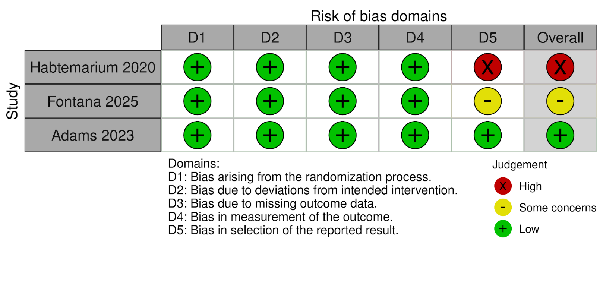
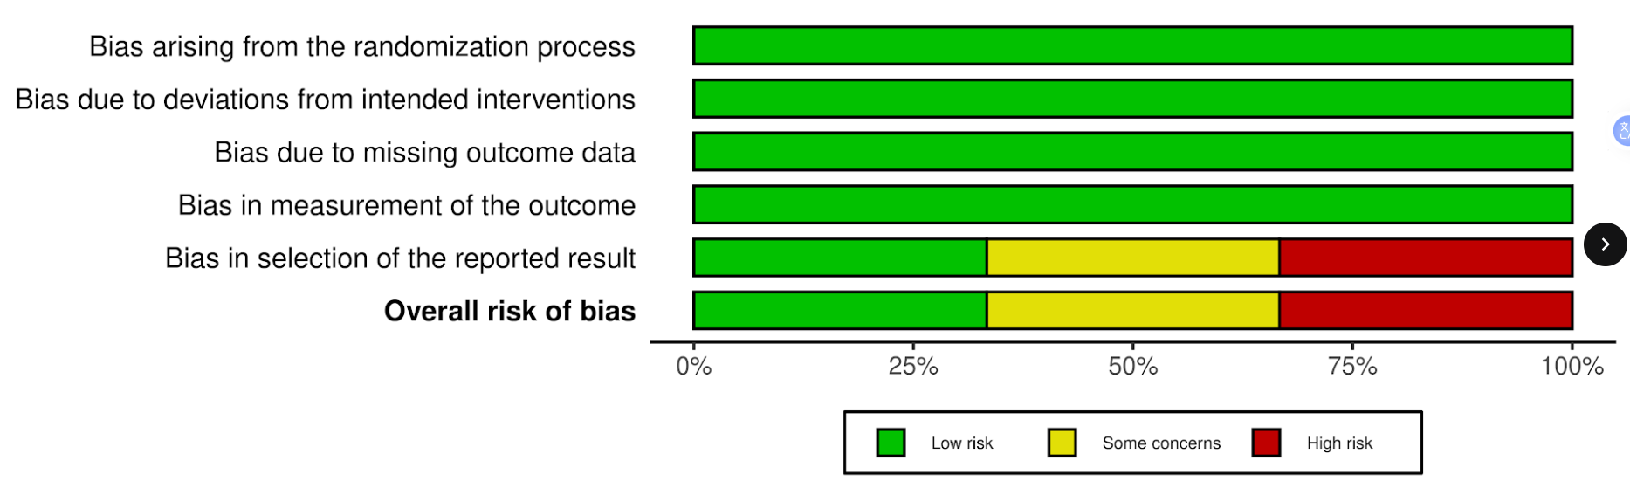
Supplementary Figure S1: Risk of Bias

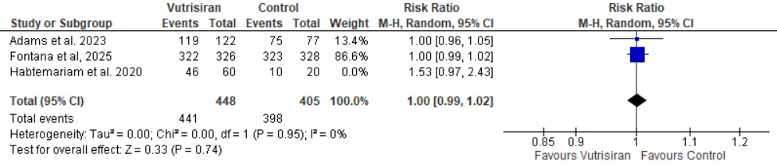
Supplementary Figure S2: Forest Plot of Sensitivity Analysis of Any Adverse Event

