Supplementary Materials

Table S1. Search Strategy
Database | Keyword | Hits
MEDLINE via PubMed | (("Milrinone"[Mesh]) OR (milrinone) OR (Phosphodiesterase 3 Inhibitors) OR (Phosphodiesterase 3 Inhibitors[Title/Abstract]))  AND  ((dobutamine) OR ("Dobutamine"[Mesh]) OR (dobutrex))  AND  ((shock) OR (cardiogenic shock[MeSH Terms])) | 159
CENTRAL via Cochrane Library | ("milrinone"):ti,ab,kw  MeSH descriptor: [Milrinone] explode all trees  #1 OR #2  (dobutamine):ti,ab,kw  MeSH descriptor: [Dobutamine] explode all trees  #4 OR #5  (cardiogenic shock):ti,ab,kw  MeSH descriptor: [Shock, Cardiogenic] explode all trees  #7 OR #8  #3 AND #6 AND #9 | 29
Scopus | ( TITLE-ABS-KEY ( milrinone ) AND TITLE-ABS-KEY ( dobutamine ) AND TITLE-ABS-KEY ( cardiogenic shock ) ) | 717

Table S2. Risk of bias of observational studies using Newcastle Ottawa Scale (NOS).
Study | Selection |  |  |  | Comparability | Outcome |  |  | Total
Study | 1 | 2 | 3 | 4 | 5 | 6 | 7 | 8 | Total
Lewis, 2019 | ☆ | ☆ | ☆ |  | ☆ | ☆ | ☆ | ☆ | 7/8
Yamani, 2001 | ☆ |  | ☆ | ☆ | ☆ | ☆ | ☆ | ☆ | 7/8
Gao, 2021 | ☆ | ☆ | ☆ | ☆ | ☆ | ☆ |  |  | 6/8
Arnold, 2006 | ☆ | ☆ |  | ☆ | ☆ | ☆ | ☆ | ☆ | 7/8
Berg, 2023 | ☆ | ☆ | ☆ | ☆ | ☆ | ☆ | ☆ | ☆ | 8/8
Hauptman, 2008 | ☆ | ☆ | ☆ | ☆ | ☆ | ☆ | ☆ | ☆ | 8/8
Nandkeolyar,2021 | ☆ | ☆ | ☆ | ☆ | ☆ | ☆ |  | ☆ | 7/8
Rodenas, 2023 | ☆ | ☆ | ☆ | ☆ | ☆ | ☆ | ☆ |  | 7/8
Sasmita, 2023 | ☆ | ☆ | ☆ | ☆ | ☆ | ☆ | ☆ |  | 7/8
Scroggins, 2005 | ☆ | ☆ | ☆ | ☆ | ☆ | ☆ |  | ☆ | 7/8
Abraham, 2005 | ☆ | ☆ | ☆ |  | ☆ |  | ☆ | ☆ | 6/8

Selection Domain
- Representativeness of the exposed cohort
- Selection of the non-exposed cohort
- Ascertainment of exposure
- Demonstration that outcome of interest was not present at start of study
Comparability Domain
- Comparability of cohorts on the basis of the design or analysis controlled for confounders
Outcome Domain
- Assessment of outcome
- Was follow-up long enough for outcomes to occur
- Adequacy of follow-up of cohor

Figure S3. Subgroup (based on setting)

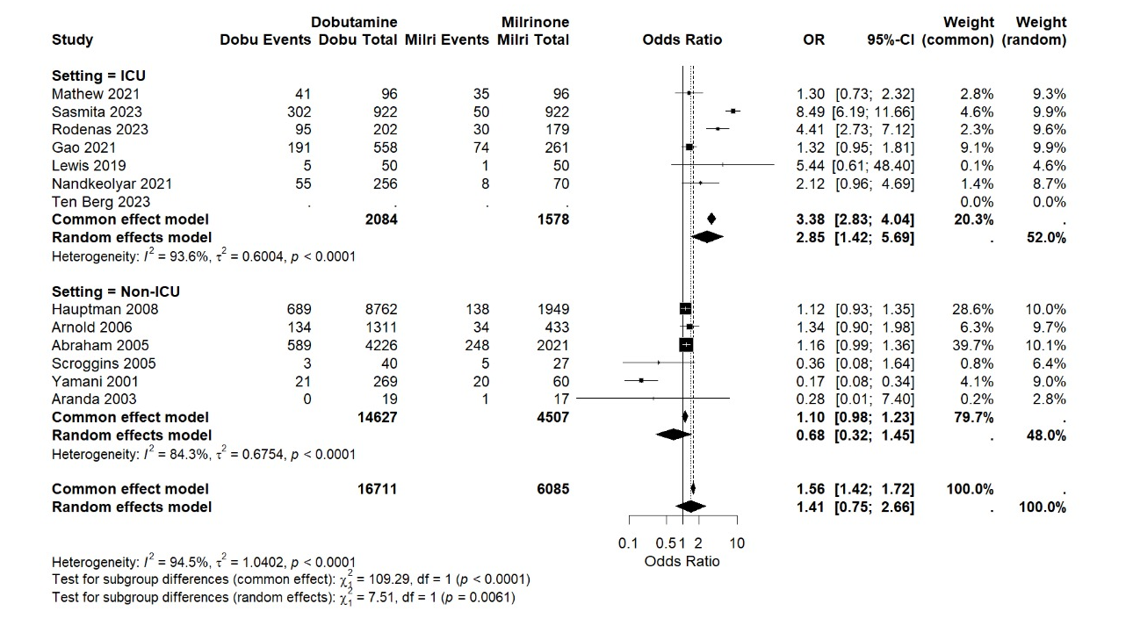

Figure S4. Subgroup (based on mechanical circulatory support)
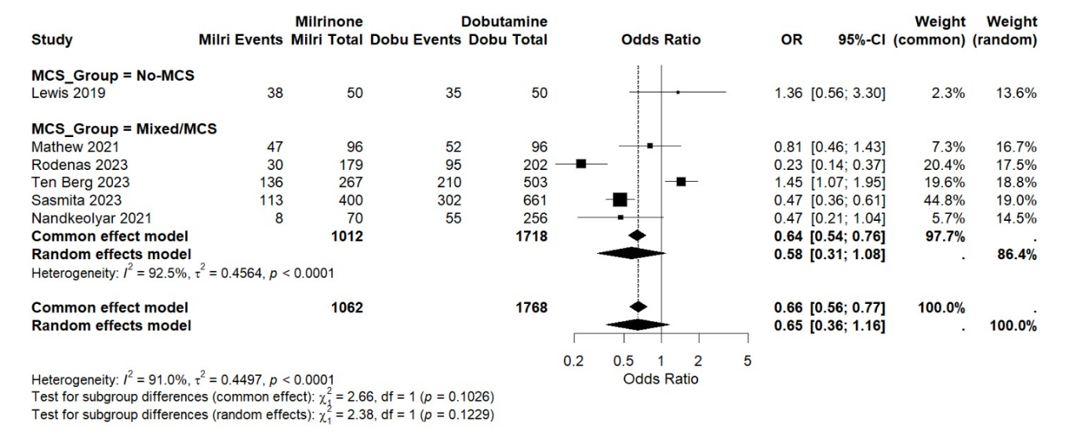

Figure S5. Subgroup ( based on adjustment method )

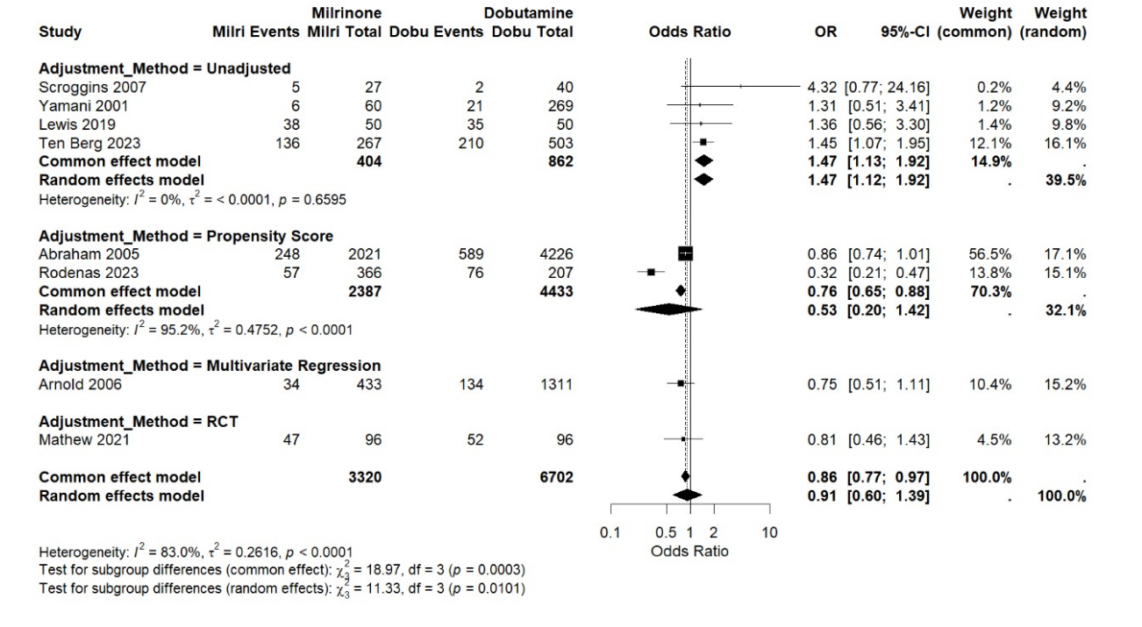

Figure S6. Subgroup (based on underlying disease)
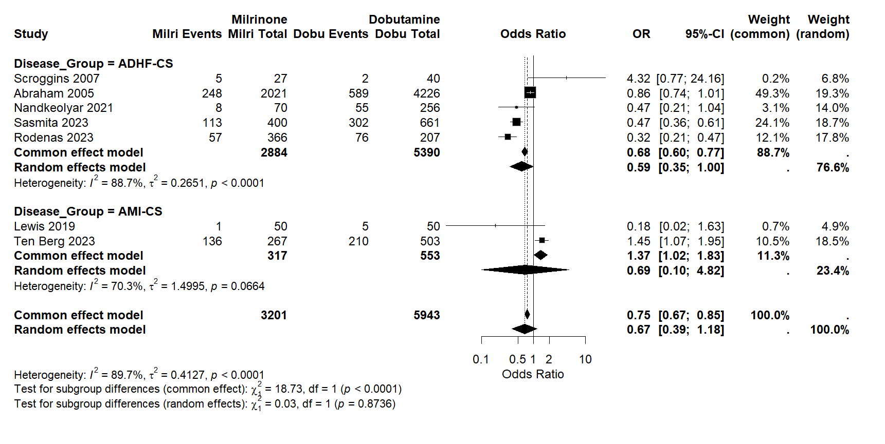

Table S4. GRADE Certainty Assesment
Dobutamine compared to Milrinone for Cardiogenic Shock
Patient or population: Cardiogenic Shock
Setting:
Intervention: Dobutamine
Comparison: Milrinone
Outcomes | № of participants  (studies)  Follow-up | Certainty of the evidence  (GRADE) | Relative effect  (95% CI) | Anticipated absolute effects
 |  |  |  | Risk with Milrinone | Risk difference with Dobutamine
RCT: In-Hospital Mortality | 228  (2 RCTs) | ⨁⨁◯◯  Low^{a,b,c,d} | OR 1.24  (0.70 to 2.19) | 32 per 100 | 5 more per 100  (from 7 fewer to 19 more)
Observational Study: In-Hospital Mortality | 23331  (11 non-randomised studies) | ⨁◯◯◯  Very low^{a,c,e} | OR 1.65  (1.04 to 2.62) | 11 per 100 | 6 more per 100  (from 0 fewer to 14 more)
RCT: All-Cause Mortality | 192  (1 RCT) | ⨁⨁⨁◯  Moderate^{c,d,f} | OR 1.30  (0.73 to 2.32) | 36 per 100 | 6 more per 100  (from 7 fewer to 21 more)
Observational Study: All-Cause Mortality | 9896  (7 non-randomised studies) | ⨁⨁◯◯  Low^{a,c,d,g} | OR 1.58  (1.06 to 2.35) | 19 per 100 | 8 more per 100  (from 1 more to 16 more)
RCT: Length-of Stay in ICU  assessed with: Days | 192  (1 RCT) | ⨁⨁⨁◯  Moderate^{c,d,f} | - | The mean RCT: Length-of Stay in ICU was 0 days | MD 1 days higher  (0.28 lower to 2.28 higher)
Observational Study: Length-of Stay in ICU  assessed with: Days | 9550  (6 non-randomised studies) | ⨁◯◯◯  Very low^{a,b,c,e} | - | The mean observational Study: Length-of Stay in ICU was 0 days | MD 0.3 days lower  (1.24 lower to 0.65 higher)
RCT: Length-of Stay in Hospital  assessed with: Days | 192  (1 RCT) | ⨁⨁⨁◯  Moderate^{c,d,f} | - | The mean RCT: Length-of Stay in Hospital was 0 days | MD 1 days lower  (5.51 lower to 3.51 higher)
Observational Length-of Stay in Hospital  assessed with: Days | 9483  (5 non-randomised studies) | ⨁◯◯◯  Very low^{a,b,c,e} | - | The mean observational Length-of Stay in Hospital was 0 days | MD 0.64 days lower  (4.8 lower to 3.52 higher)
RCT: Significant Arrhythmias in Hospital | 228  (2 RCTs) | ⨁⨁⨁◯  Moderate^{a,c,d} | OR 1.19  (0.71 to 2.01) | 46 per 100 | 4 more per 100  (from 8 fewer to 17 more)
Observational Study: Significant Arrhythmias in Hospital | 452  (2 non-randomised studies) | ⨁◯◯◯  Very low^{b,c,d,e} | OR 0.66  (0.13 to 3.40) | 42 per 100 | 10 fewer per 100  (from 33 fewer to 29 more)
RCT: Acute Renal Failure | 316  (2 RCTs) | ⨁⨁⨁◯  Moderate^{c,d} | OR 0.88  (0.50 to 1.54) | 76 per 100 | 2 fewer per 100  (from 15 fewer to 7 more)
Observational Study: Acute Renal Failure | 2791  (3 non-randomised studies) | ⨁⨁⨁⨁  High | OR 1.22  (1.00 to 1.47) | 22 per 100 | 4 more per 100  (from 0 fewer to 7 more)
*The risk in the intervention group (and its 95% confidence interval) is based on the assumed risk in the comparison group and the relative effect of the intervention (and its 95% CI).
CI: confidence interval; MD: mean difference; OR: odds ratio
GRADE Working Group grades of evidence
High certainty: we are very confident that the true effect lies close to that of the estimate of the effect.
Moderate certainty: we are moderately confident in the effect estimate: the true effect is likely to be close to the estimate of the effect, but there is a possibility that it is substantially different.
Low certainty: our confidence in the effect estimate is limited: the true effect may be substantially different from the estimate of the effect.
Very low certainty: we have very little confidence in the effect estimate: the true effect is likely to be substantially different from the estimate of effect.

Explanations
a. Risk of bias are unlikely to lower confidence in the estimate of effect.
b. There is variation in direction of effect between studies.
c. Wide confidence intervals.
d. Number of events does not meet the optimal information size.
e. Statistical analyses showing considerable heterogeneity.
f. None as only a single study was included for this outcome.
g. Statistical analyses showing substantial heterogeneity.

